Exp No:10a -Analysis of Critical Frequency and Maximum Usable Frequency (MUF) using MATLAB

Code:
clc;
clear;
close all;

%% EXPERIMENT 10a
% Analysis of Critical Frequency and Maximum Usable Frequency (MUF)

%% Objective 1: Critical Frequency Analysis

Nmax = 0.1:0.05:1.0; % Electron Density (10^12 electrons/m^3)

fc = 9*sqrt(Nmax); % Critical Frequency (MHz)

%% Objective 2: MUF Analysis

theta = 0:1:70; % Angle of Incidence (degrees)

fc_fixed = 6.3; % Critical Frequency (MHz)

MUF = fc_fixed*sec(deg2rad(theta));

%% Objective 3: Comparative Analysis

MUF_ratio = MUF/fc_fixed;

%% Display Results

fprintf('\nCRITICAL FREQUENCY AND MUF ANALYSIS\n');
fprintf('-------------------------------------\n');

fprintf('Critical Frequency = %.2f MHz\n',fc_fixed);

fprintf('MUF at 60 Degree = %.2f MHz\n', ...
fc_fixed*sec(deg2rad(60)));

%% Plot Results

figure('Name','Critical Frequency and MUF Analysis', ...
'NumberTitle','off');

% Graph 1: Critical Frequency vs Electron Density

subplot(2,2,1);

plot(Nmax,fc,'LineWidth',2);

grid on;

xlabel('Electron Density (10^{12} electrons/m^3)');
ylabel('Critical Frequency (MHz)');

title('Critical Frequency vs Electron Density');

% Graph 2: MUF vs Angle of Incidence

subplot(2,2,2);

plot(theta,MUF,'LineWidth',2);

grid on;

xlabel('Angle of Incidence (Degree)');
ylabel('MUF (MHz)');

title('MUF vs Angle of Incidence');

% Graph 3: MUF Ratio

subplot(2,2,3);

plot(theta,MUF_ratio,'LineWidth',2);

grid on;

xlabel('Angle of Incidence (Degree)');
ylabel('MUF/fc');

title('MUF Ratio');

% Graph 4: Comparison of Critical Frequency and MUF

subplot(2,2,4);

plot(theta,MUF,'LineWidth',2);

hold on;

yline(fc_fixed,'--','LineWidth',2);

grid on;

legend('MUF','Critical Frequency');

xlabel('Angle (Degree)');
ylabel('Frequency (MHz)');

title('Comparison of fc and MUF');

fprintf('\nSimulation completed successfully.\n');

Output:

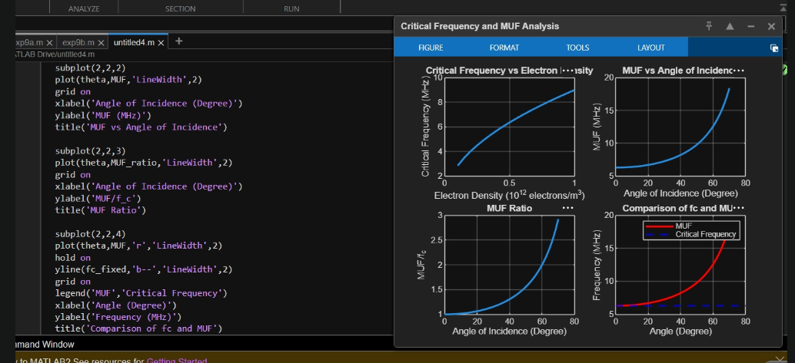

Exp No:10b:Analysis of Skip Distance and Tropospheric Propagation using MATLAB

Code:
clc;
clear;
close all;

%% EXPERIMENT 10b
% Analysis of Skip Distance and Tropospheric Propagation using MATLAB
%% Objective 1: Skip Distance Analysis
h = 250; % Ionospheric Height (km)
theta = 10:1:70; % Angle of Incidence (degrees)
Skip_Distance = 2*h*tand(theta);
%% Objective 2: Tropospheric Propagation
ht = 100; % Transmitter Height (m)
hr = 50; % Receiver Height (m)
LOS_Distance = 4.12*(sqrt(ht)+sqrt(hr));
%% Objective 3: Comparative Analysis
Coverage_Ratio = Skip_Distance/LOS_Distance;
%% Display Results
fprintf('\nSKIP DISTANCE AND TROPOSPHERIC PROPAGATION ANALYSIS\n');
fprintf('---------------------------------------------------\n');
fprintf('Ionospheric Height = %.2f km\n',h);
fprintf('Skip Distance at 60° = %.2f km\n', ...
2*h*tand(60));
fprintf('LOS Distance = %.2f km\n',LOS_Distance);
fprintf('Coverage Ratio = %.2f\n', ...
(2*h*tand(60))/LOS_Distance);
%% Plot Results
figure('Name','Skip Distance and Tropospheric Propagation', ...
'NumberTitle','off');
% Graph 1: Skip Distance vs Angle
subplot(2,2,1);
plot(theta,Skip_Distance,'LineWidth',2);
grid on;
xlabel('Angle of Incidence (Degree)');
ylabel('Skip Distance (km)');
title('Skip Distance vs Angle');
% Graph 2: Tropospheric LOS Distance
subplot(2,2,2);
bar(LOS_Distance);
grid on;
title('Tropospheric LOS Distance');
ylabel('Distance (km)');
set(gca,'XTickLabel',{'LOS Range'});
% Graph 3: Coverage Ratio
subplot(2,2,3);
plot(theta,Coverage_Ratio,'LineWidth',2);
grid on;
xlabel('Angle of Incidence (Degree)');
ylabel('Coverage Ratio');
title('Coverage Ratio Analysis');
% Graph 4: Sky Wave vs Tropospheric Propagation
subplot(2,2,4);
plot(theta,Skip_Distance,'LineWidth',2);
hold on;
yline(LOS_Distance,'--','LineWidth',2);
grid on;
legend('Skip Distance','LOS Distance');
xlabel('Angle (Degree)');
ylabel('Distance (km)');
title('Comparison of Sky Wave and Tropospheric Propagation');
fprintf('\nSimulation completed successfully.\n');

Output:

